

OJAS CREATIVE CUSTOMER DOCUMENTATION

Ojas Creative — Ojas Stream
Complete Installation, Customization & Feature Guide
Kajabi Course/Product template • Version 7.1.4 • SomaStream demo

Template scope Ojas Stream is installed inside a Kajabi Course/Product. It does not replace the main Kajabi Website template. This guide covers installation, every major editor feature, native Community activation, member testing, launch, updates and troubleshooting.

How to use this guide
- New customers: follow Parts 1–3 in order, then complete the launch checklist.
- Existing customers: use the Feature Reference and Troubleshooting sections as an operator handbook.
- Always test with a non-admin member. Kajabi admin Preview can bypass normal access rules.

Contents
- 1. Before installation
- 2. Install and activate safely
- 3. Recommended setup order
- 4. Sections reference
- 5. Global settings reference
- 6. Community activation — complete workflow
- 7. Course content and access states
- 8. Post player, audio, downloads and comments
- 9. Search, favorites, announcements and navigation
- 10. Mobile experience
- 11. Testing and launch
- 12. Updating and rollback
- 13. Troubleshooting
- 14. Final checklist

1. Before installation
PROTECT THE LIVE MEMBER EXPERIENCE
- Confirm the correct Kajabi site and Course/Product.
- Keep the current active Course template installed for rollback.
- Download the original Ojas Stream ZIP and do not extract or re-zip it.
- Prepare transparent light/dark logos, favicon, brand colors, fonts, category thumbnails, lesson media, instructor details and navigation URLs.
- Review the Course outline for published, draft, locked, drip and completed states.
- Create a non-admin test member with the same access a real customer will receive.

2. Install and activate safely
- Open Kajabi Admin → Products → Courses and select the intended Course.
- Open Customize, then choose Install Template → Upload Template.
- Upload the untouched Ojas Stream ZIP and wait for Kajabi processing.
- Confirm the installed metadata reads Ojas Creative — Ojas Stream 7.1.4.
- Open Customize and configure the new template while the previous template stays live.
- Use Preview and a non-admin member account for desktop/mobile QA.
- Only after QA, return to Customize and select Activate on Ojas Stream.
Important Installing a template does not publish it. Activation is a separate Kajabi action. Activation changes presentation; Course content, Offers, customers, payments, progress and access remain controlled by Kajabi.

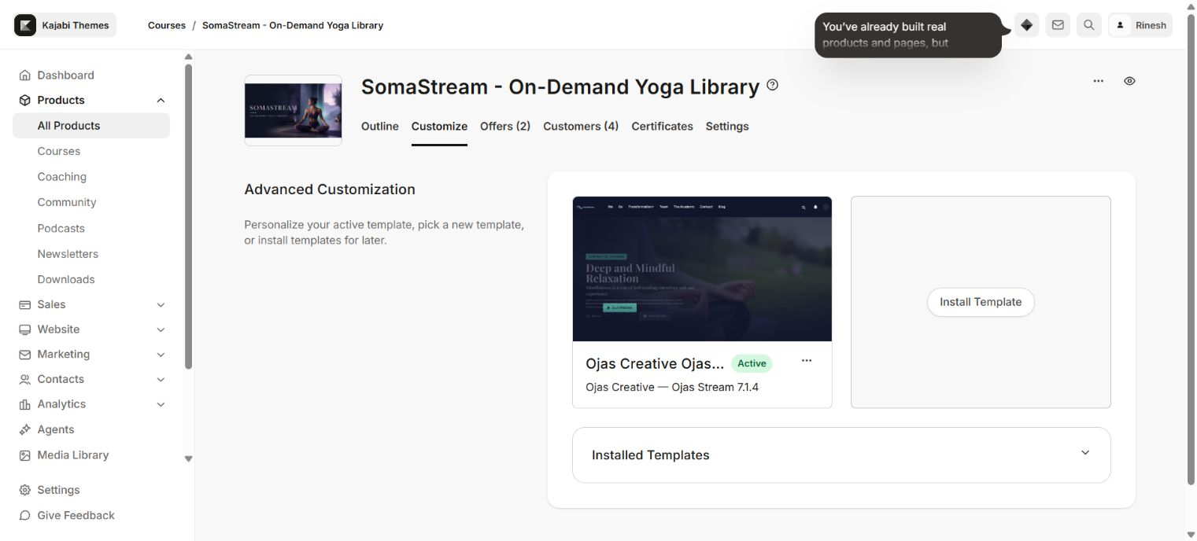
Install Ojas Stream in the selected Course and activate it only after testing.

3. Recommended setup order
- Brand and OJAS Theme Colors
- Typography
- Header and Footer
- Product Home hero and category presentation
- Post media and lesson labels
- Search, favorites, announcements and navigation
- Community
- Mobile tab bar and safe-area testing
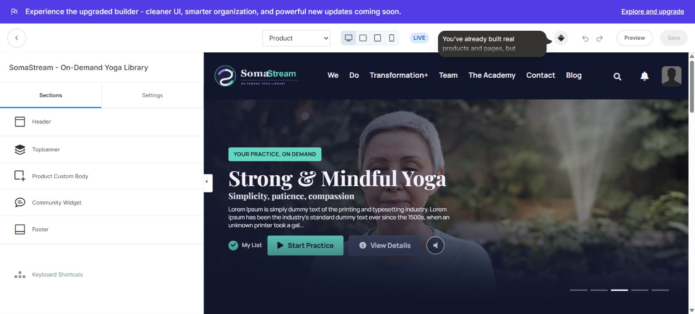
The Ojas Stream editor separates page sections from global settings.
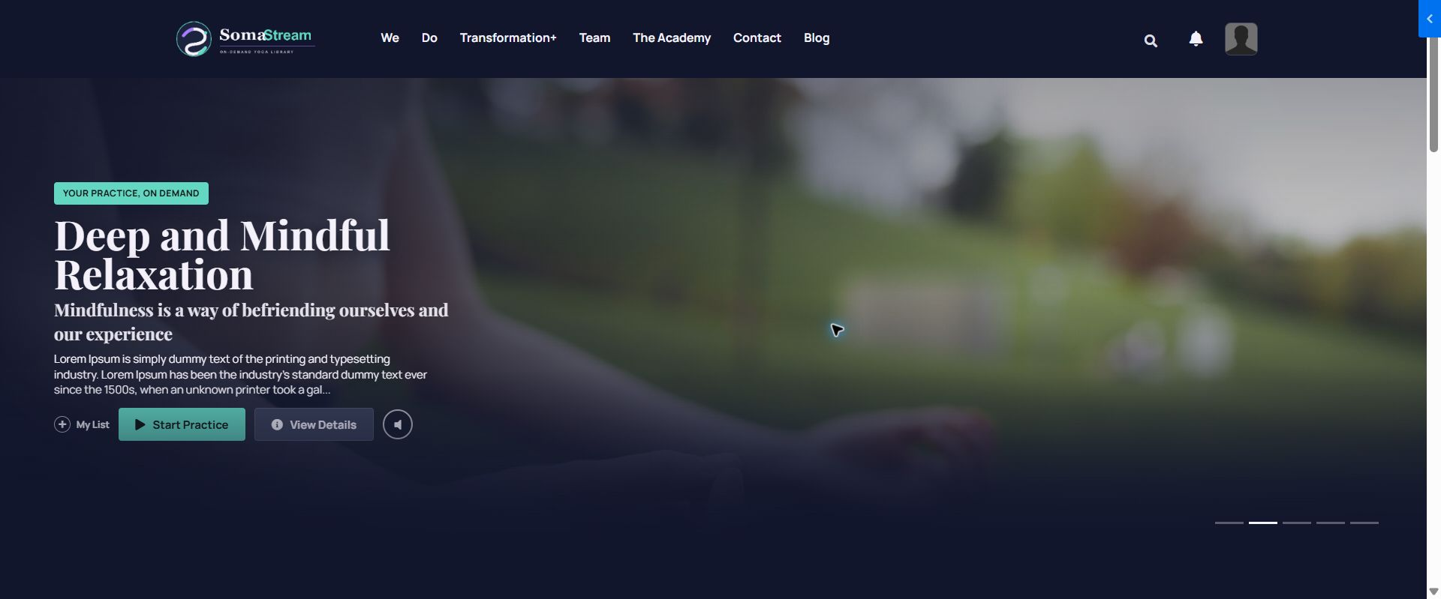
Use a real member preview to verify the configured experience.

4. Sections reference
Area | What you can configure
Header | Show/hide header, image or text logo, desktop/mobile dimensions, logo action, menu visibility, labels, links and optional announcement.
Topbanner | Hero slider mode, right-side video, video URL/poster, autoplay and playback controls.
Product Custom Body | Enable custom Product Home content and add/reorder supported video, text, image and mixed blocks; choose position, card width and style.
Community Widget | Community copy, popup labels, channel selection, access guidance, image/title/fonts and setup empty states.
Footer | Logo and responsive dimensions, brand copy, copyright, Course link, social links and mobile tab-bar labels.
Post Media | Show/hide player, Course details, instructor info and additional sidebar video/image/text/mixed content.
Product Banner | Show/hide promotional banner and configure two actions.
Dashboard Body | Repeatable video, text and image blocks on the member dashboard.
Dashboard Sidebar | Repeatable card, video, text and image blocks for supporting member content.
Navigation | Show lesson/post navigation and configure navigation title/progress/action controls.
Search Results | Control the search result presentation and no-result experience.
Category views | Cinematic category hero, outline/progress, category banner override and per-category color treatments.

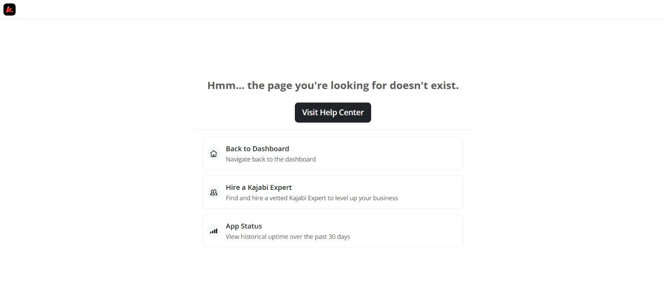
Header controls include responsive logo dimensions and member navigation.
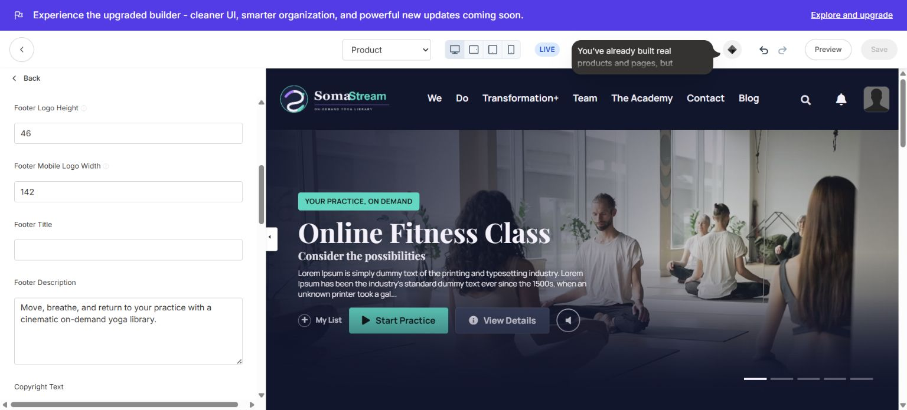
Footer settings include brand details, links and mobile tab-bar labels.

5. Global settings reference
Area | What you can configure
Brand | Favicon and favorites label.
OJAS Theme Colors | Accent/buttons, brand tone, surfaces/cards and page background.
Typography | Body/heading families, optional custom scale, body desktop/mobile and H1–H6 desktop/mobile sizes.
Header, Menu & Search | Search visibility/placeholder; previous/next; hero labels; resume, details, My List and account labels.
Homepage Category Text | Category kicker, heading, Explore labels and drip/scheduled/locked/lesson-count text.
Course Display | Dashboard, Categories tab, custom landing page, category thumbnails and lesson thumbnails.
Post Page Text | Module, assessment, audio, download, watch, completed, categories popup, progress, favorites, comment and empty-state copy.
Advanced | Autoplay behavior, hover styles and corner shapes.
Community Experience | Hide, inline bottom section, header popup, or both; plus the accessibility label.

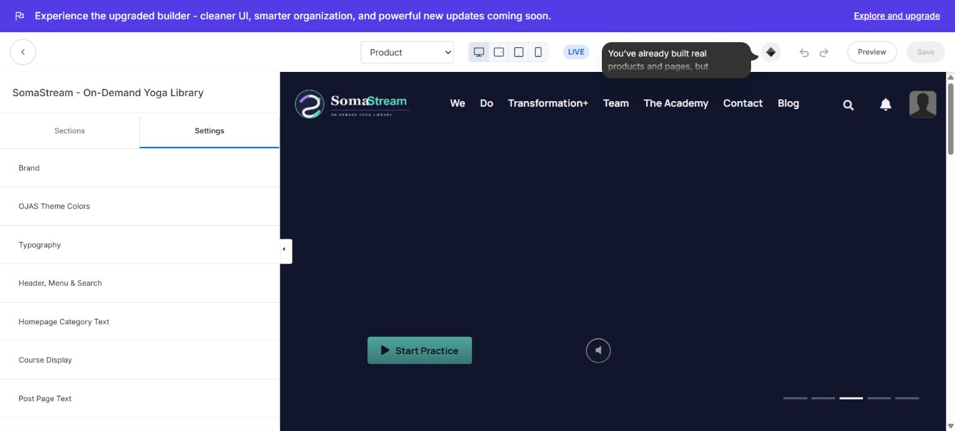
Global settings control brand, typography, labels, Course display and advanced behavior.

6. Community activation — complete workflow
KAJABI-NATIVE ACCESS, NEVER A PERMISSION BYPASS
- In Kajabi, create or confirm the native Community and the channel/circle you want Course members to use.
- Confirm the Course/Offer grants the correct Community access group. A member without this access can see Unauthorized even when the template is configured correctly.
- Open Ojas Stream Customize → Product page → Sections → Community Widget.
- Choose the Community Channel. The editor reminds you to add the access group containing that channel to the Offers linked to the Course.
- Set the section eyebrow, heading, description, popup button text, close label and accessibility label.
- Enable Link to Community channel settings only when you want the template control to take admins to Kajabi’s channel settings.
- Open Settings → Community Experience and choose Hide Community, Bottom Section Only, Header Popup Only, or Bottom Section + Header Popup.
- Save, then test with a non-admin member who owns the same Offer/access group. Test both desktop and a real mobile browser.
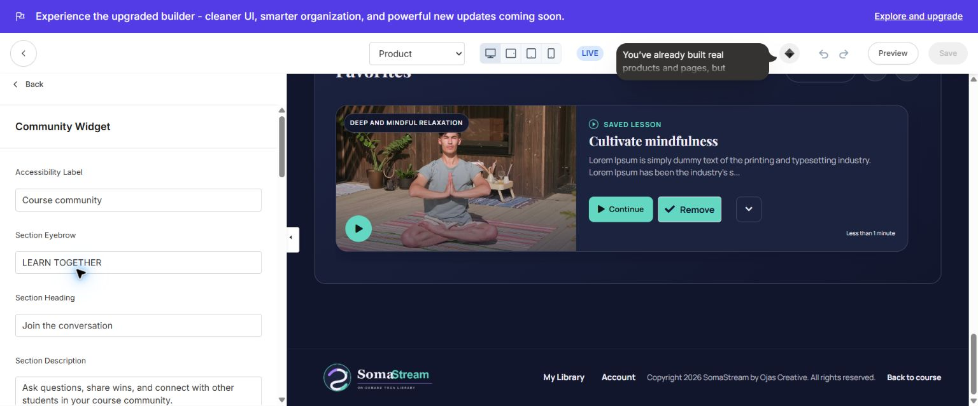
Community Widget: choose the Kajabi channel and configure labels and setup states.
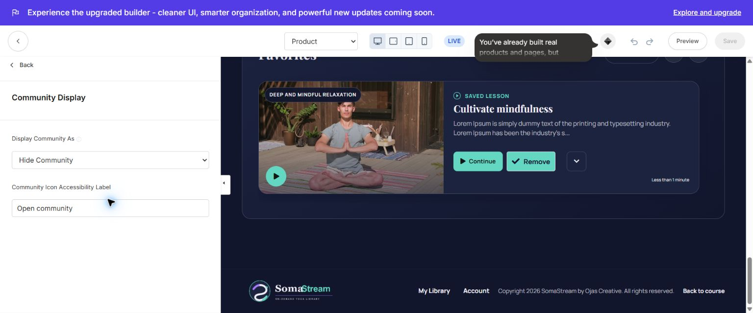
Community Experience: choose exactly where the Community appears.
If Community stays blank or says Unauthorized First open the same Community/channel outside Ojas Stream or temporarily compare with Kajabi’s default Course template. If it fails there too, fix Kajabi member, Offer and access-group permissions. The Ojas Stream theme cannot and should not bypass Kajabi authorization.

7. Course content and access states
Area | What you can configure
Course/Product | The complete branded member experience.
Module/Category | A member journey collection, category rail and outline group.
Lesson/Post | Playable content with media, progress, text, downloads and navigation.
Locked | Shown as unavailable until Kajabi grants access; verify the lock label and click protection.
Drip/Scheduled | Uses Kajabi availability rules and the configured labels.
Draft/Unpublished | Hidden from normal members until published.
Completed | Kajabi progress drives completion badges, progress indicators and Continue Watching.

- Keep titles concise enough for mobile cards and drawers.
- Use consistent 16:9 category and lesson media with a clear focal point.
- Test a member who has access and another who does not.

8. Post player, audio, downloads and comments
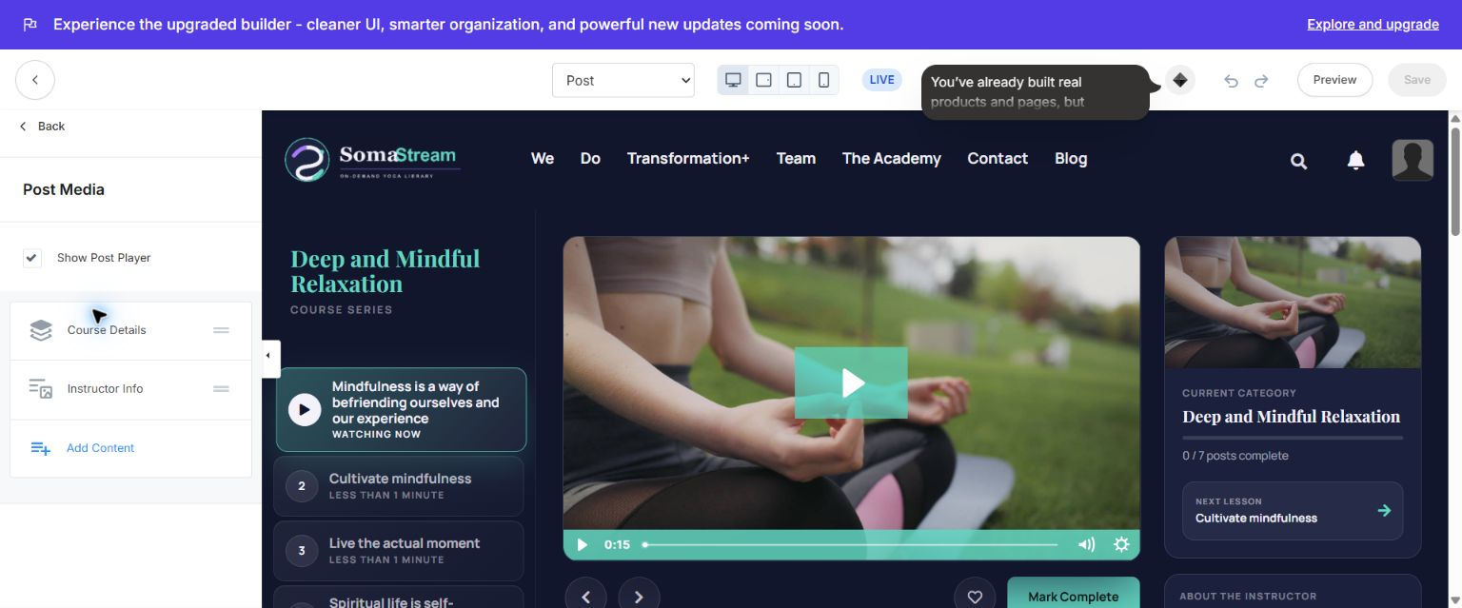
Post Media controls the lesson player, Course details, instructor panel and supporting media blocks.
- Use Show Post Player to display or hide the primary lesson player.
- Configure Course Details and Instructor Info from their blocks.
- Use Add Content for supported sidebar video, image, text, image+text and video+text content.
- Add accessible media titles, thumbnails/covers and useful filenames for downloads.
- When Kajabi Course comments are disabled, verify the full comment section disappears; do not leave an empty visual shell.
- Check audio play/pause icons and durations on desktop and mobile.

9. Search, favorites, announcements and navigation
- Search uses the labels and placeholders under Header, Menu & Search and Post Page Text.
- Favorites/My List appears only when Kajabi member data supports it; configure both action and empty-state labels.
- Announcements use Kajabi’s announcement data and the configured Read More label.
- Previous/next navigation must respect locked, draft and unavailable content.
- Category popup, search, announcement, Community and account overlays should close with their visible close control and Escape where supported.

10. Mobile experience
- Configure mobile logo dimensions separately from desktop.
- Keep mobile tab labels short and test bottom safe-area spacing on iPhone and Android.
- Verify Course outline, search, announcements, Community and account overlays are readable, scrollable and not hidden under browser navigation.
- Test long lesson/module titles for wrapping rather than clipping.
- Verify footer, instructor card, progress card and comments do not overlap the fixed bottom tab bar.

11. Testing and launch
- Desktop: header, sidebar, hero, category rails, cards, modals, footer and long pages.
- Mobile: drawer, fixed tab bar, progress, popups, safe areas, long titles and touch targets.
- Media: video, audio, thumbnails, captions, downloads and external links.
- Access: purchased, unpurchased, locked, drip, completed, draft and unpublished states.
- Member tools: search, announcements, comments, favorites and Community.
- Real member: open from Library, resume a lesson, mark complete and confirm progress is recorded.
- Activate Ojas Stream, then repeat the critical checkout-to-access and member tests.

12. Updating and rollback
- Download the latest official ZIP and review release notes.
- Keep the customized live template installed as rollback.
- Install the new version beside the live version unless the release explicitly supports an in-place update.
- Reapply/compare settings and complete QA.
- Activate only after verification; reactivate the prior template if rollback is needed.

13. Troubleshooting
Area | What you can configure
ZIP rejected | Use the original Course/Product template ZIP; do not extract or re-zip it.
Installed but not live | Preview it, then use the separate Activate action.
Logo missing/oversized | Re-select the image, save and set desktop/mobile dimensions separately.
Cards empty | Publish the relevant modules/lessons and add media.
Locked state wrong | Verify Kajabi access/drip settings and test as a restricted member.
Community blank | Confirm channel selection, Offer access group and non-admin member permission.
Community Unauthorized | Test the native Kajabi Community directly; fix Kajabi authorization before theme styling.
Comments shell remains | Disable Course comments, save and verify the entire section is hidden.
Mobile overlap | Shorten labels and verify modal, footer and bottom-nav safe areas.
Changes look stale | Save, refresh and confirm the intended Course, page type and template version are active.

14. Final launch checklist
- ☐ Correct Course selected; original ZIP installed; Ojas Creative — Ojas Stream 7.1.4 confirmed.
- ☐ Brand, colors, typography, header, footer and Course display configured.
- ☐ Product Home, categories, posts, locked/drip states and instructor content configured.
- ☐ Community channel and Offer access group tested with a non-admin member.
- ☐ Search, favorites, announcements, comments, media and downloads tested.
- ☐ Desktop, real mobile, accessibility and purchase-to-access tests passed.
- ☐ Demonstration copy, media and links removed.
- ☐ Previous template retained for rollback.
Support request checklist Include template version, affected Course page, browser/device, a cropped screenshot and exact reproduction steps. Never share Kajabi passwords, customer data, payment credentials, API keys or access tokens.

