OJAS CREATIVE / COURSE THEME GUIDE

Ojas Creative —
Ojas Bloom
  - Installation, customization & launch guide
A practical guide for installing and preparing the premium Ojas Bloom Kajabi Course template for Bloom Within — 28-Day Yoga & Self-Care Journey.
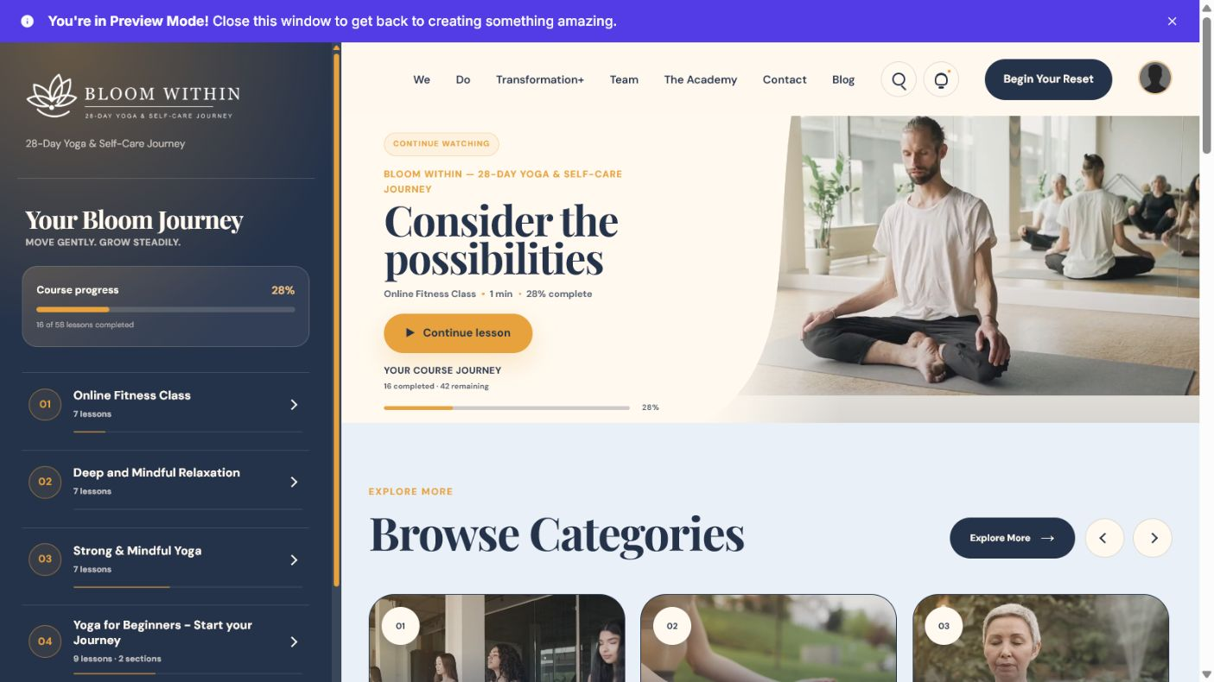
TEMPLATE  Ojas Creative — Ojas Bloom | EXPERIENCE  Kajabi Course / Member area | GUIDE VERSION  1.0 • July 29, 2026
DEMO COURSE  Bloom Within — 28-Day Yoga & Self-Care Journey | RECOMMENDED FOR  Yoga, wellness and self-care | SUPPORT  support@ojascreative.com

Quick start
Use this safe order to install without interrupting an existing live Course experience.
01 | Confirm the correct Kajabi Course  Open Products and verify the Course title before changing its theme.

02 | Upload and install Ojas Bloom  Install the supplied theme ZIP from the Course design/theme area.

03 | Customize a duplicate first  Keep the current live theme active while you update branding, navigation and Course content.

04 | Preview the member experience  Review desktop and mobile layouts, locked content, progress, lesson navigation and downloads.

05 | Activate only after approval  Publish the finished theme when the final checklist is complete.

Before you begin
- Keep an untouched backup of the downloaded Ojas Bloom ZIP.
- Prepare your transparent logo, brand colors, instructor image and support links.
- Confirm that Course modules, lessons, access rules and offers already work in Kajabi.
- Do not delete the currently active theme until the replacement is fully tested.

1. Confirm the correct Course
In Kajabi, open Products and select “Bloom Within — 28-Day Yoga & Self-Care Journey.” Check the module list, published lessons, locked content and draft content before making design changes.
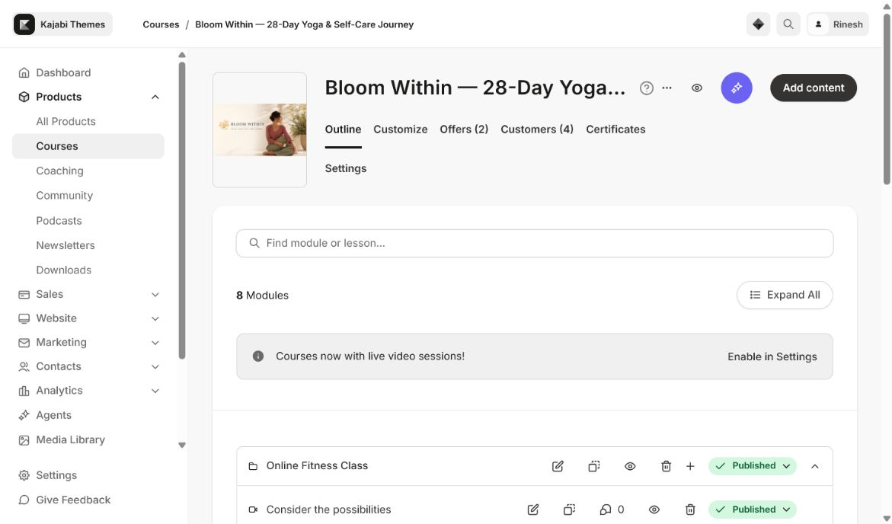
Real Kajabi Course outline used for this guide.

2. Install Ojas Bloom
- Open the Course theme/design screen.
- Upload the supplied Ojas Bloom ZIP and wait for Kajabi to finish processing it.
- Confirm the installed metadata reads “Ojas Creative — Ojas Bloom”.
- Choose Customize on the new installation; do not activate it yet.

3. Customize the experience
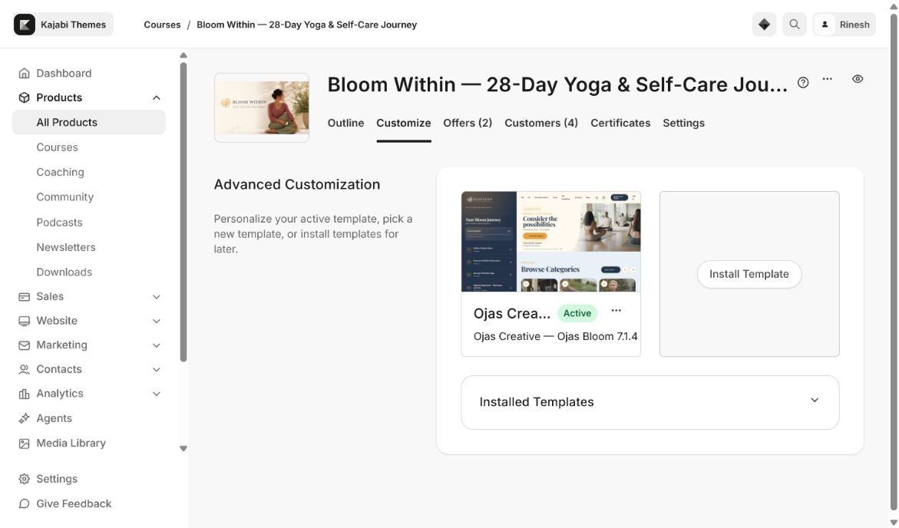
Replace demo branding and copy inside Kajabi’s visual editor. Keep the layout structure intact until the first full preview is complete.
Area | Replace with | Check
Brand | Transparent logo, colors, typography | Readable on light and dark media
Navigation | Useful Course/member links only | No broken or duplicate links
Course content | Real module and lesson copy | No lorem ipsum or demo labels
Instructor | Name, photo and short bio | Accurate and approved
Support/legal | Support, privacy and terms links | Open in the correct destination

Content preparation
- Use concise lesson titles that remain readable in the sidebar and mobile Course outline.
- Add appropriate thumbnails, video, audio and downloadable files to each lesson.
- Configure locked/dripped modules in Kajabi; the theme visually reflects Kajabi access state.
- Disable comments at product/lesson level when the comment area should be completely hidden.

4. Test before activation
- Desktop and mobile navigation open and close correctly.
- Video, audio, downloads, lesson completion and next/previous controls work.
- Progress totals match Kajabi and locked modules display a clear locked state.
- Long titles wrap cleanly without covering icons or buttons.
- Community, search and announcements use valid Kajabi destinations for the signed-in member.
- Footer and mobile navigation do not overlap Course content.

5. Activate safely
When every check passes, return to the Course theme screen and activate Ojas Bloom. Open the Course once as a member after activation. Keep the previous theme available as a rollback option.

Updating later
For future releases, install the new ZIP as a separate theme, copy your approved settings, test it, and then activate it. Do not overwrite your only working installation.

Troubleshooting
Issue | What to check
Theme will not upload | Use the original ZIP. Do not unzip/re-zip it with an extra parent folder.
Logo looks blurry | Upload a transparent high-resolution PNG or SVG and confirm its display width.
Locked category looks empty | Confirm Kajabi access/lock settings and that the category has a title and thumbnail.
Mobile footer overlaps content | Recheck the latest Ojas Bloom release and test in a fresh browser session.
Comments leave an empty shell | Save comments as disabled at product/lesson level and refresh the member preview.
Community does not open | Verify the member has Community access and that Kajabi permits the destination in that session.

Final launch checklist
- Correct Course and correct Ojas Bloom installation confirmed
- Demo logo, copy and links replaced
- Published, locked and draft content verified
- Desktop and mobile member journeys tested
- Video, audio, downloads, progress and comments checked
- Previous working theme retained for rollback
Need help? Contact support@ojascreative.com with the Kajabi Course URL, installed theme version, device/browser and a screenshot of the issue.

