OJAS CREATIVE
Ojas Aura
Single-Page Kajabi Course Template
Installation, customization, testing & launch guide
VERSION 7.1.4 • CUSTOMER GUIDE

Build a polished member experience without touching your course content.
Ojas Creative — Ojas Aura is a single-page Kajabi Course/Product template: the member’s lesson, course navigation, progress, media, downloads, and supporting content are brought together in one focused responsive experience. Your modules, lessons, customers, offers, purchases, and progress remain managed by Kajabi.
Important
Install Ojas Aura from the selected Course → Customize tab. Do not upload it in Website → Design. Keep the ZIP compressed and retain your current active template as a rollback option.

Quick start
1. Open the correct Kajabi Course and verify its Outline.
2. Open Customize → Install Template → Upload Template.
3. Upload the original Ojas Aura ZIP and leave the existing template active.
4. Customize branding, navigation, lesson pages, and member tools.
5. Preview on desktop and mobile, test with a non-admin member, then activate.

PART 1

Install Ojas Aura safely

1. Confirm the correct Course
Open Products → Courses, select the Course that should use Ojas Aura, and verify that the expected modules and lessons are present. Each Kajabi Course has its own Course template.
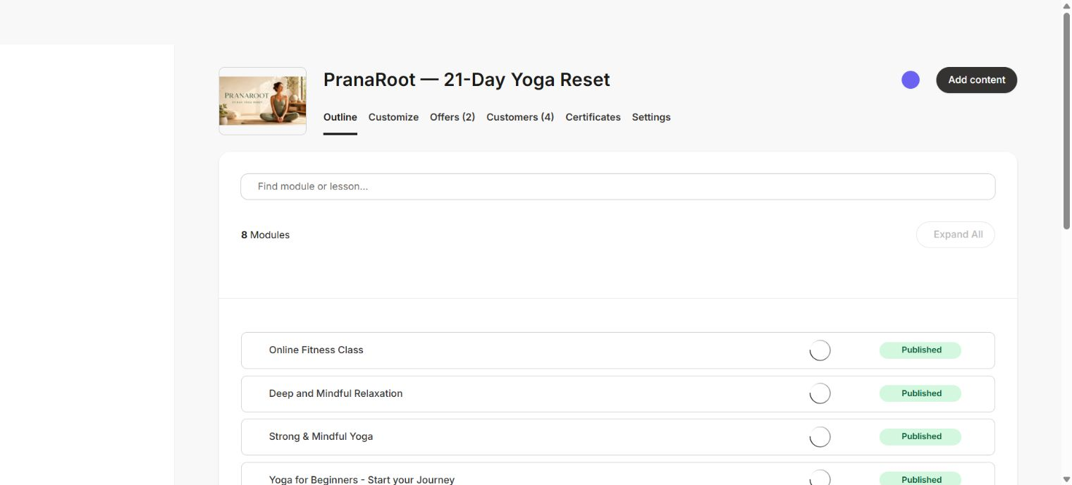
Confirm the Course and its content outline before changing the template.

2. Install the template
1. Open the Course’s Customize tab.
2. Choose Install Template, then Upload Template.
3. Select the untouched Ojas Aura ZIP. Do not extract or re-zip it.
4. Wait for Kajabi to finish processing the package.
5. Keep the existing template active while you customize and test Ojas Aura.
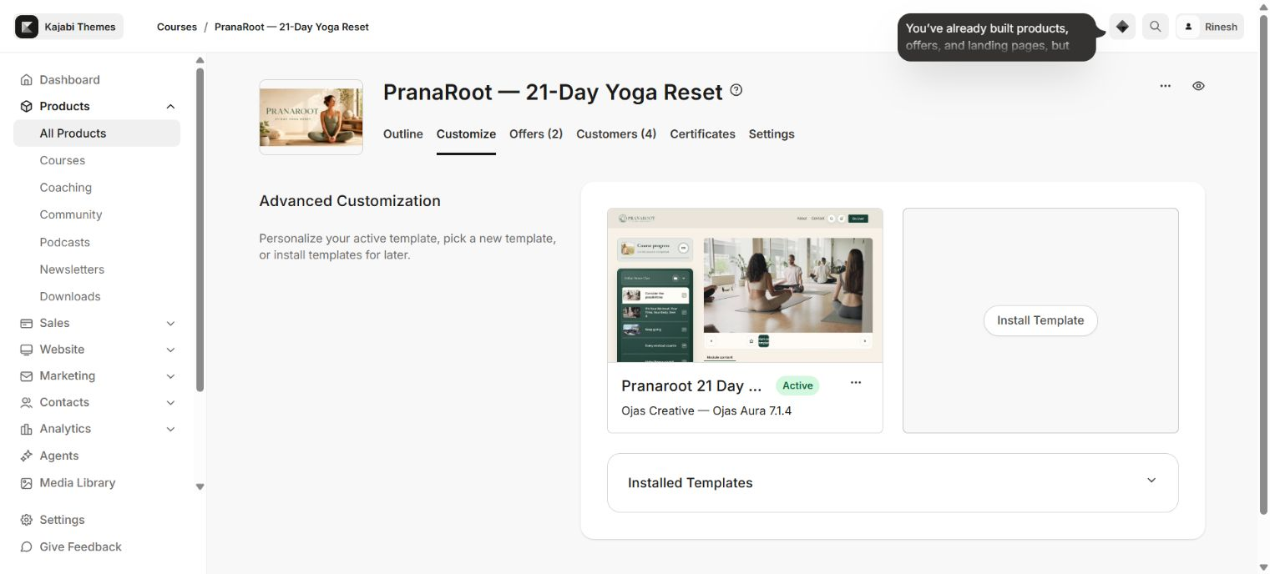
Ojas Creative — Ojas Aura 7.1.4 installed beside the active Course template.
Name and format check
The template metadata should read “Ojas Creative — Ojas Aura”. It is a Single-Page Kajabi Course Template. PranaRoot is the demo Course brand shown in these screenshots, not the template name.

PART 2

Customize the theme

Understand the editor
Use the page selector at the top to review Product, Categories, Category, Post/Lesson, Search, Announcements, and Comment experiences. Page sections live in the left sidebar; global brand settings control the shared identity.
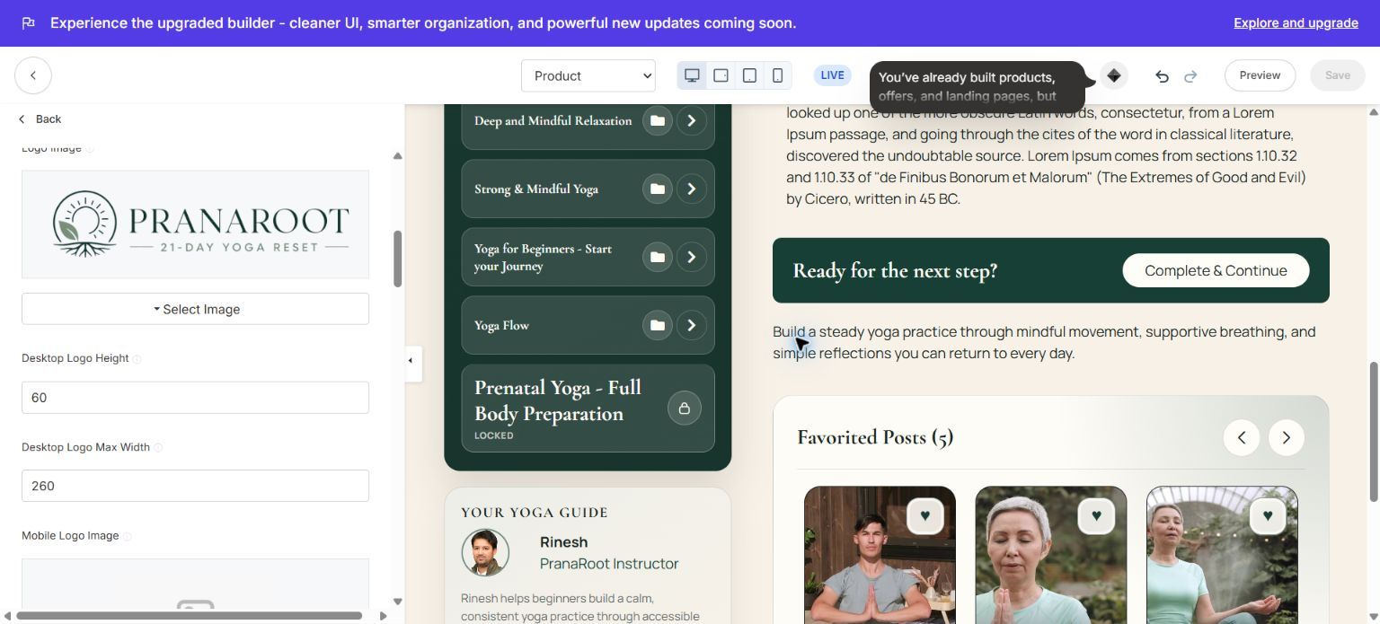
Kajabi’s Course template editor with Ojas Aura settings and the live preview canvas.

Recommended setup order
1. Logo and identity: upload transparent desktop and mobile logo files and set sensible maximum dimensions.
2. Colors: apply a readable background, high-contrast text, restrained borders, and one clear action color.
3. Typography: choose a readable body font and a distinctive but legible heading font.
4. Header and navigation: keep member links short and test search, announcements, account, and logout.
5. Course structure: use concise module and lesson titles with consistent thumbnail ratios.
6. Lesson experience: review video, audio, downloads, completion controls, favorites, comments, and next/previous navigation.

PART 3

Shape the member experience
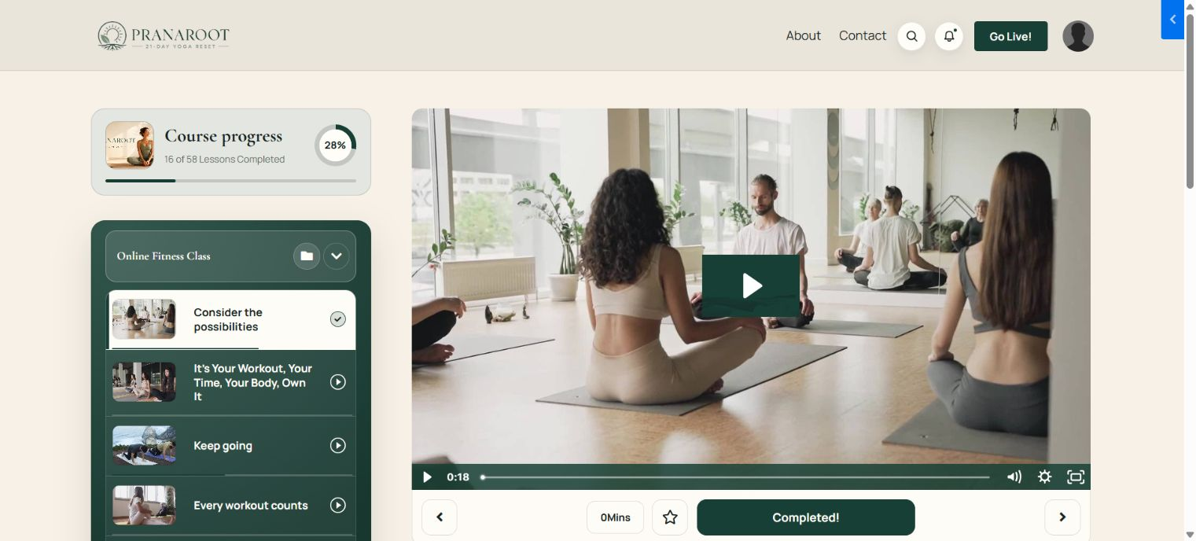
A real Ojas Aura member preview using the PranaRoot yoga Course as demonstration content.

How Kajabi content maps to Ojas Aura
AREA | WHAT TO VERIFY
Course | The complete member product styled by Ojas Aura.
Module | A grouped category inside the Course outline.
Lesson | A playable content item with progress, media, downloads, and description.
Locked content | Clearly labelled and unavailable until Kajabi grants access.
Progress | Calculated by Kajabi and displayed by the theme.
Community | Uses Kajabi access and permissions; availability depends on the member’s Kajabi account.

Content preparation
- Use short, meaningful module and lesson names.
- Upload consistent, high-quality thumbnails with a clear focal point.
- Replace all placeholder or Lorem ipsum copy before launch.
- Add captions, downloads, lesson summaries, and completion guidance where useful.
- Keep locked and drip content intentional; test both accessible and restricted states.
- Disable comments where conversation is not needed and confirm the entire comments card disappears.

PART 4

Preview, test, and activate

Quality assurance checklist
AREA | WHAT TO VERIFY
Desktop | Header, sidebar, video, lesson content, cards, footer, and long pages align correctly.
Mobile | Course outline, progress card, footer, bottom navigation, modals, and text have safe spacing.
Media | Video controls, audio icons, progress bar, downloads, and external links work.
States | Locked, drip, completed, unpublished, empty, and no-result states look intentional.
Member tools | Search, announcements, comments, favorites, and community respect Kajabi permissions.
Real account | A non-admin test member can open the Course from the Library and complete a lesson.

Do not rely only on editor Preview
Open the Course with a non-admin member account in a separate browser or private window. Admin sessions can bypass access restrictions and hide member-only problems.

Activate safely
1. Return to Course → Customize.
2. Confirm Ojas Creative — Ojas Aura is the version you tested.
3. Keep the previous active template installed as a rollback option.
4. Open the Ojas Aura menu and choose Activate.
5. Repeat the member test after activation.
Activating a Course template changes presentation only. Your Course outline, offers, customers, purchases, progress, and access rules remain in Kajabi.

PART 5

Updates, troubleshooting & support

Updating Ojas Aura
1. Download the latest Ojas Aura ZIP and read its release notes.
2. Retain or export the customized live template as a backup.
3. Install the new version beside the live version unless the release explicitly supports an in-place update.
4. Reapply or compare settings, then repeat desktop, mobile, and real-member QA.
5. Activate the new version only after verification.

Troubleshooting
AREA | WHAT TO VERIFY
ZIP will not upload | Use the original Course/Product template ZIP from the customer dashboard.
Installed but not visible | Customize and preview it, then use the separate Activate action.
Logo missing | Re-select the image, save, check transparency and contrast, then refresh Preview.
Cards are empty | Publish the relevant modules/lessons and add suitable thumbnails.
Locked card looks wrong | Verify Kajabi access settings and test with a real restricted member.
Comments shell remains | Disable Course comments, save, and confirm the full comments section is hidden.
Community does not load | Verify the member has Kajabi Community access; test Kajabi’s default template too.
Mobile overlap | Shorten labels, check image ratios, and test the member bottom navigation and modal safe area.
Changes appear stale | Save, refresh the member page, and confirm the intended template is active.

When contacting support
- Ojas Aura version number.
- Affected Course page and whether the issue appears on desktop, mobile, or both.
- Browser and device details.
- A cropped screenshot or short screen recording.
- Exact steps needed to reproduce the issue.
Protect your account
Never send Kajabi passwords, payment credentials, customer data, private download links, or API keys in a support message.

Final launch sign-off
- Correct Course selected and original ZIP installed.
- Template name displays as Ojas Creative — Ojas Aura.
- Brand, typography, header, navigation, modules, and lesson pages configured.
- Placeholder copy and media removed.
- Desktop, mobile, accessibility, restricted-state, and real-member tests passed.
- Previous template retained as rollback.
READY TO LAUNCH
Your single-page Course experience is ready for members.
Activate only after the real-member checklist passes, and keep the previous template available for a fast rollback.

