CUSTOMER INSTALLATION MANUAL

CineFlow
Netflix-Style Kajabi Product Theme
Install • Customize • Test • Launch
A practical, screenshot-based guide for installing CineFlow in a Kajabi Course, applying your brand, organizing Netflix-style content rows, and activating the experience safely.
Version 1.0 • July 2026
Designed for Kajabi Course and membership products
IMPORTANT CineFlow is a Course/Product template. Install it from the selected Kajabi Course’s Customize tab—not from Website Design.

How to use this guide
Follow the Quick Start first if you already know Kajabi. New users should continue through the complete setup, using the screenshots to match the current Kajabi interface.

What CineFlow changes
- The member-facing Course home, category/module, lesson/post, search, announcement, and comment pages.
- The product header, navigation, colors, typography, labels, hero presentation, content rows, and card styling.
- The visual experience inside the selected Course only. It does not automatically redesign your marketing website, checkout, Offers, or email templates.

Quick Start
- Download the original CineFlow ZIP and keep it compressed.
- In Kajabi, open Products → Courses and select the Course you want to style.
- Open Customize, choose Install Template, then Upload Template.
- Upload the CineFlow ZIP. Do not activate it yet.
- Customize the installed CineFlow template, then preview every page on desktop and mobile.
- Activate CineFlow only after the launch checklist passes.
SAFE WORKFLOW Installing a template does not make it visible to customers. Kajabi requires a separate Activate action, so you can build and test CineFlow behind the scenes first.

Before you begin
- ☐ Kajabi admin access to the correct site and Course.
- ☐ The untouched CineFlow .zip file downloaded from your marketplace account.
- ☐ A backup/export of the currently active Course template.
- ☐ Logo, favicon, brand colors, font choices, card thumbnails, and hero media.
- ☐ Published Course modules and lessons, with clear titles and descriptions.

1. Open the correct Kajabi Course
- Sign in to Kajabi and open Products → Courses.
- Select the Course or membership product that should use CineFlow.
- Confirm the Outline contains the modules and lessons you expect.
- Open the Customize tab at the top of the Course editor.
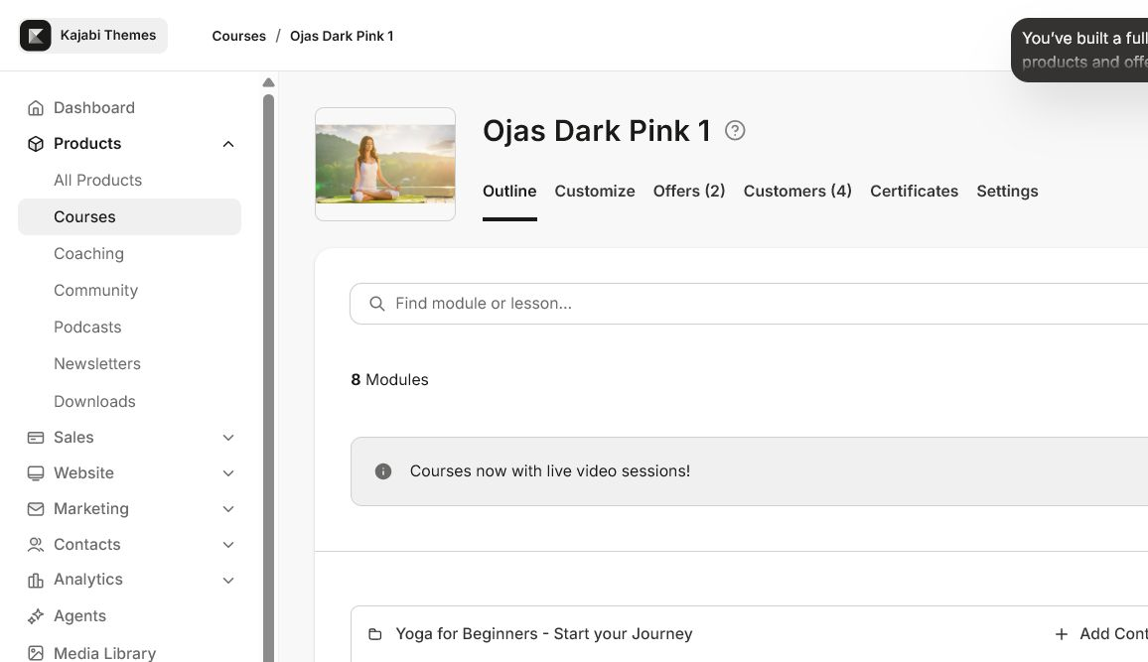
Kajabi Course editor: verify the correct product and content outline before changing its template.
WHY THIS MATTERS A Course template is installed per Course. If your Kajabi site contains several Courses, repeat the installation only for the products that should use CineFlow.

2. Upload CineFlow
- On the Customize screen, choose Install Template.
- Choose Upload Template and select the original CineFlow ZIP.
- Wait for Kajabi to finish installing the template.
- If available, rename the installed template to “CineFlow – your course name” so it is easy to identify.
- Leave your current template active while you configure and test CineFlow.
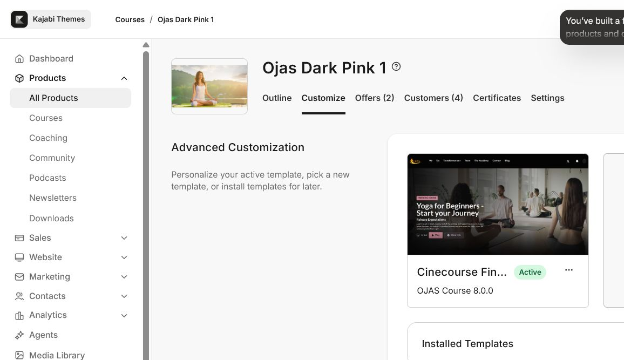
The Customize tab shows the active template and other installed templates. Use the template menu to customize, rename, export, or activate.
DO NOT UNZIP Upload the downloaded .zip file as provided. Do not upload a folder, a re-zipped nested folder, or a Website template ZIP.

3. Understand the CineFlow editor
Open the CineFlow template’s menu and choose Customize. Kajabi’s visual editor has three areas:
- Top page selector: switch between Product, Categories, Category, Post/Lesson, Search, Announcements, and Comment pages.
- Left sidebar: Sections controls page-specific layout; Settings controls global brand and theme options.
- Preview canvas: shows the member-facing page. Use Preview for a full browser test and Save to keep your changes.
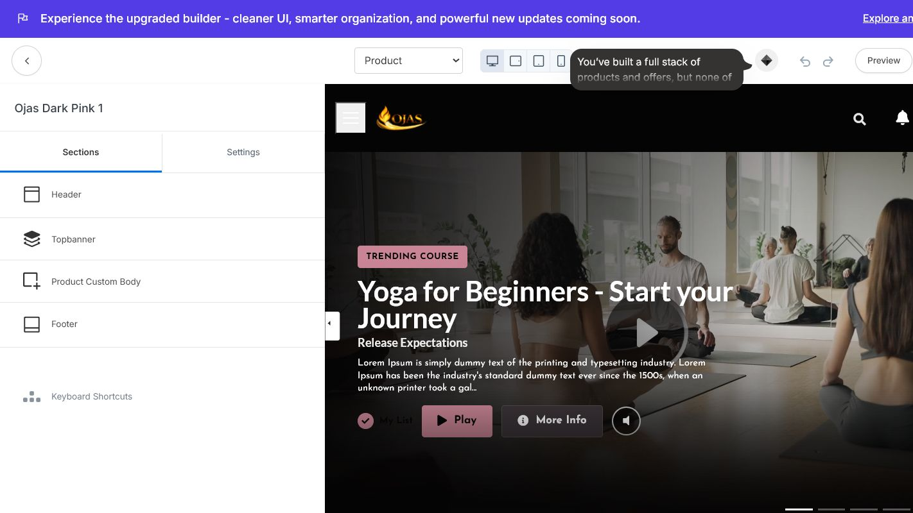
CineFlow editor overview: page selector, Sections/Settings sidebar, preview canvas, Preview link, and Save button.
SAVE VS. ACTIVATE Save stores your edits inside the installed template. Activate makes that template visible to customers. Saving alone does not replace the live template.

Page-by-page setup order
- Product: configure the main Course home, hero, categories, and content rows.
- Categories and Category: confirm browsing, titles, thumbnails, and empty states.
- Post: confirm lesson video/content, progress, resources, and next/previous navigation.
- Search: test common lesson and module names.
- Announcements and Comment: check typography, spacing, and member actions.

4. Apply your brand
Start in Settings so the global design is consistent before you fine-tune individual sections.
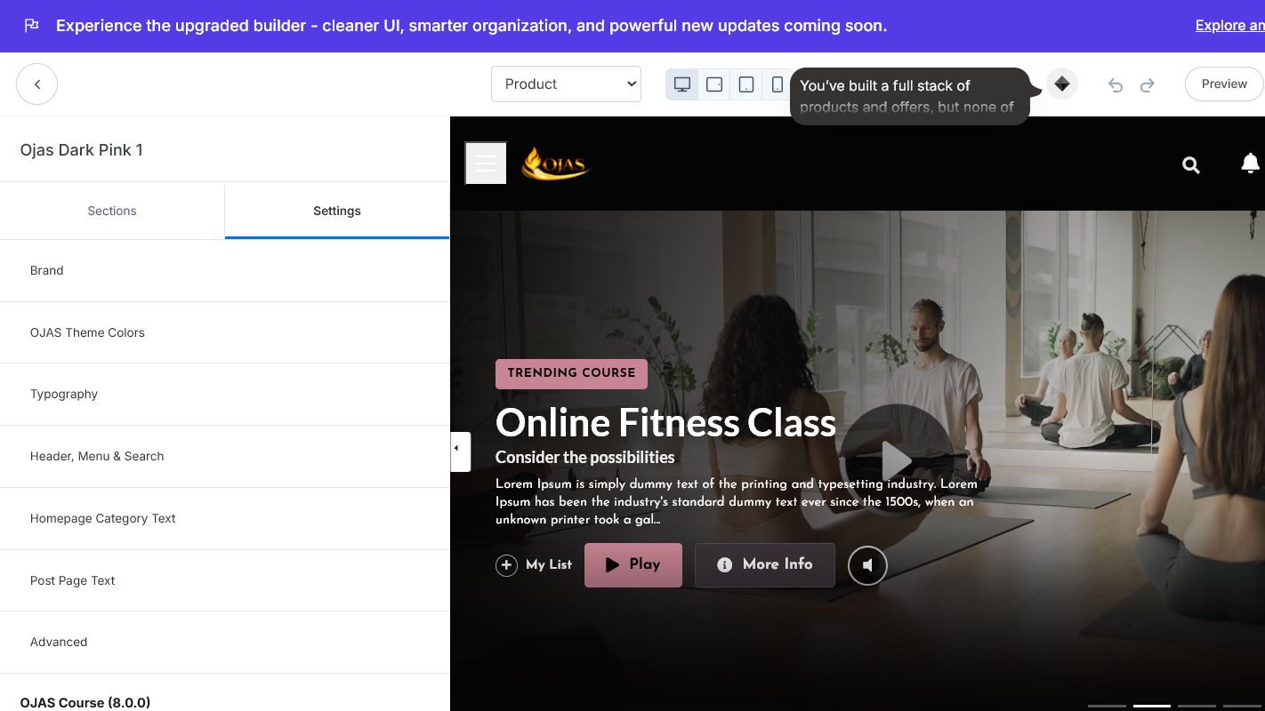
CineFlow global settings include Brand, theme colors, typography, header/menu/search, homepage text, post text, and advanced options.
Area | Recommended setup
Logo | Use a transparent PNG or SVG-style asset supported by Kajabi. Keep clear space around the mark.
Favicon | Use a clean square icon, ideally prepared at 512 × 512 px.
Theme colors | Use near-black backgrounds, high-contrast white text, and one restrained accent color.
Typography | Choose a readable body font and a stronger display font. Avoid more than two font families.
Hero media | Use a consistent 16:9 image or video with a clear focal point and readable overlay text.
Content cards | Use consistent 16:9 thumbnails so each Netflix-style row feels intentional.
ACCESSIBILITY Check text contrast, button labels, focus states, and mobile readability. Never place critical text only inside an image.

Recommended CineFlow visual recipe
- Background: deep navy or near-black rather than pure black.
- Primary text: warm white; secondary text: cool gray with enough contrast.
- Accent: one brand color for buttons, active states, progress, and highlights.
- Cards: consistent imagery, short titles, and subtle hover/focus treatment.
- Spacing: keep sections generous and avoid overloading the hero with copy.

5. Configure the header and navigation
Open Settings → Header/Menu/Search. CineFlow can use either a text logo or an image logo and can connect the top menu to a Kajabi navigation link list.
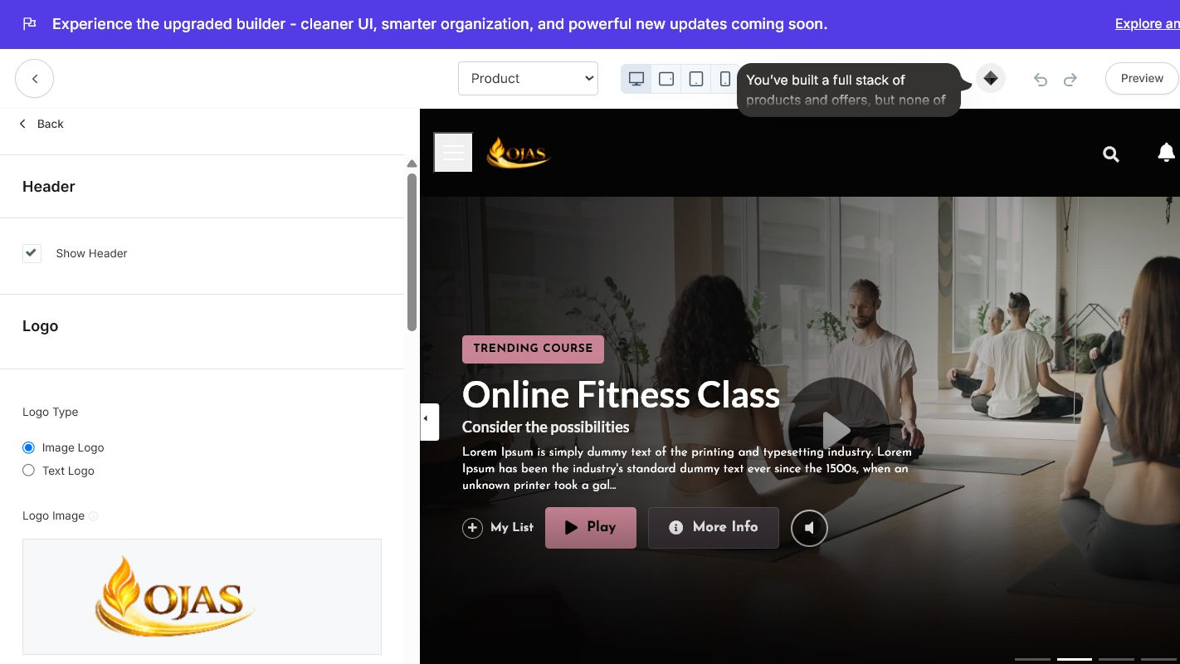
Header settings: logo type, logo height, logo action, navigation link list, user-menu labels, and optional announcement.

Header checklist
- ☐ Choose Image Logo or Text Logo and confirm it remains readable on a dark background.
- ☐ Set Logo Action to Product Home unless you intentionally want members to leave the Course.
- ☐ Select a short Kajabi navigation menu; remove links that do not help the learning experience.
- ☐ Use clear labels for Library, Favorites/My List, Search, Account, and Logout.
- ☐ Enable an announcement only when it adds timely value; keep it short.
MENU SOURCE If a header link is wrong, update the selected Kajabi navigation link list or choose a different list in CineFlow’s Menu setting.

6. Build the Netflix-style content experience
CineFlow uses your Kajabi Course structure. A clean content model produces a cleaner interface.
Area | Recommended setup
Kajabi Course | The complete product shown to the member.
Module | A category or horizontal content row, such as Start Here, Yoga, or Advanced Training.
Lesson | A playable content card with title, thumbnail, video/content, and progress.
Thumbnail | The visual cover for a lesson card. Keep aspect ratio and art direction consistent.
Description | Short supporting copy for featured content and lesson discovery.
Publish/Drip | Controls when members can access content; verify locked and scheduled states.

Content preparation
- Rename modules as clear browsing categories.
- Keep lesson titles short enough to scan on cards and mobile screens.
- Add a consistent thumbnail to every visible lesson.
- Check lesson videos, downloads, captions, descriptions, and next-step links.
- Publish or schedule content intentionally; do not use missing content as a design test.
TIP Use 5–8 strong cards in a row rather than many inconsistent cards. Content quality affects the perceived quality of the theme.

Product home
- Choose one featured item with a strong hero image/video and a clear action.
- Put your most important module first: Start Here, New Releases, or Continue Learning.
- Use homepage/category labels that match your audience’s language.
- Check that member progress and favorites display correctly with real member data.

7. Preview and quality assurance
Preview CineFlow before activation. Test both the visual editor preview and the full member experience in a separate browser session.

Desktop and mobile
- ☐ Header, logo, search, navigation, account menu, and logout are usable.
- ☐ Hero media loads, text remains readable, and the primary action works.
- ☐ Content rows scroll and cards do not clip or overlap.
- ☐ Module/category and lesson/post pages match the global colors and typography.
- ☐ Lesson video, captions, downloads, progress, next/previous, and completion work.
- ☐ Search returns relevant lessons and handles no-result states.
- ☐ Favorites/My List works for a real test member if enabled.
- ☐ Locked, drip, unpublished, completed, and empty states look intentional.
- ☐ Mobile cards, menus, tap targets, and long titles remain usable.

Test as the customer
- Create or use a non-admin test member with access to the Course.
- Open the Course from the member Library, not only from the editor Preview.
- Complete a lesson, navigate back, search, favorite content, and resume playback.
- Repeat in an incognito/private window and on a phone when possible.
PRIVACY Do not send support screenshots containing customer names, emails, order data, or admin credentials. Crop screenshots to the relevant interface area.

Performance basics
- Compress hero images and thumbnails before upload.
- Avoid oversized GIFs and unnecessary autoplay media.
- Use Kajabi-hosted media or a reliable video host supported by your setup.
- Test the first page load on mobile data, not only on fast Wi-Fi.

8. Activate CineFlow safely
When the full checklist passes, return to the Course’s Customize tab.
- Confirm CineFlow is the installed template you customized.
- Export or clearly retain the previous active template as your rollback option.
- Open the CineFlow template menu and choose Activate.
- Open the Course as a test member and repeat the critical launch checks.
- Keep the previous template installed until the live experience is verified.
ROLLBACK If a serious display or navigation issue appears, reactivate the previous template while you correct CineFlow. Content, Offers, customers, and purchases remain separate from the template design.

Updating CineFlow later
- Download the new CineFlow ZIP and read its release notes.
- Export your customized current template as a backup.
- Install the update alongside the live template unless the update specifically supports an in-place third-party theme upgrade.
- Reapply or compare settings as required, preview every page, then activate the tested version.
- Keep only clearly named, known-good templates to avoid activating the wrong version.
KAJABI NOTE Kajabi’s third-party ZIP upgrade feature is documented as beta for selected accounts. Use it only if it is available in your account and the CineFlow release explicitly supports it.

9. Troubleshooting

Template will not upload
Use the original Course/Product template ZIP. Download it again if needed; do not unzip and repackage it. Confirm you are in the Course’s Customize tab, not Website Design.

CineFlow is installed but not visible
Installation does not make a template live. Preview it first, then choose Activate from the CineFlow template menu when ready.

Logo or favicon is missing
Re-select the asset in Brand or Header settings, save, and confirm the file type and contrast against the header background.

Menu links are wrong
Select the correct Kajabi navigation link list in Header/Menu/Search and edit that link list in Kajabi if necessary.

Cards or rows are empty
Confirm modules and lessons are published, assigned correctly, and contain thumbnails. Test with a member who has access.

A lesson looks unstyled
Use the top page selector to open Post/Lesson and configure its Sections and Settings separately.

Changes do not appear
Save the editor, refresh Preview, verify you are editing the intended installed template, and check whether another template is active.

Mobile layout feels crowded
Shorten titles, use consistent thumbnails, reduce optional menu items, and review every page in mobile preview.

Video does not autoplay
Browser autoplay policies can block sound. Use a user-initiated play action or muted autoplay where supported, and always provide visible controls.

What to include in a support request
- CineFlow version and Kajabi Course name (no customer data).
- Affected page type: Product, Category, Post/Lesson, Search, Announcement, or Comment.
- Browser, device, and screen size.
- A cropped screenshot and the exact steps that reproduce the issue.
- Whether the issue occurs in editor Preview, as a real member, or both.

Final launch checklist
- ☐ Correct Kajabi Course selected.
- ☐ Original CineFlow ZIP installed and clearly named.
- ☐ Brand, colors, typography, header, and navigation configured.
- ☐ Modules and lessons organized into clear browsing rows.
- ☐ Every visible lesson has a suitable thumbnail and working content.
- ☐ Product, Categories, Category, Post, Search, Announcements, and Comment pages reviewed.
- ☐ Desktop and mobile previews passed.
- ☐ Real test-member experience passed in a separate browser session.
- ☐ Previous active template retained as a rollback option.
- ☐ CineFlow activated only after all checks passed.

Official Kajabi references
Course templates — install, customize, and activate: Kajabi Help Center
Preview a Course/Product before publishing: Kajabi Help Center
Rename and export a Course template: Kajabi Help Center
Access the Course template code editor (eligible plans): Kajabi Help Center
GUIDE SCOPE Kajabi may update interface labels over time. If a label differs, use the same functional path: Products → Courses → selected Course → Customize.

